

**Bright World**

|  |  |  |
| --- | --- | --- |
| **Supervisor:** | *LÊ THANH NHÂN* | |
| **Semester:** | *II* | |
| **Batch No:** | *T1.2112.E0* | |
| **Group No:** | *1* | |
| **Order:** | **Full name** | **Roll No.** |
| *1.* | *Khưu Nguyễn Lan Anh* | *Student1352176* |
| *2.* | *Huỳnh Thanh Tú* | *Student1357831* |
| *3.* | *Nguyễn Minh Sơn* | *Student1352243* |
| *4.* | *Vũ Đông Nam* | *Student1352239* |

***Month****: 10* ***Year****:2022*



This is to certify that

|  |  |
| --- | --- |
| **Ms.** | **KHƯU NGUYỄN LAN ANH** |
| **Mr.** | **HUỲNH THANH TÚ** |
| **Mr.** | **NGUYỄN MINH SƠN** |
| **Mr.** | **VŨ ĐÔNG NAM** |

Have successfully Designed & Developed

|  |  |  |
| --- | --- | --- |
|  |  |  |
| **BRIGHT WORLD** | | |

Submitted by:

|  |
| --- |
| **Mr. LE THANH NHAN** |

Date Of Issue:

|  |  |
| --- | --- |
|  |  |

Authorized Signature:

|  |  |
| --- | --- |
|  |  |
| **Content** | | | |

Content

Acknowledge

Synposis

Review1 7

Review2 14

Review3 13

Testting Document 44

Final Checklist 45

Tasksheet 46

|  |
| --- |
| **Acknowledge** |

As we understand that the Project is a step-by- step learning environmnent that closely simulates the class-room and Lab based learning environment into actual implementation It is a projectimplementation at your fingertips An electronic, live juncture on the machine that allows you to.

* Practice step by step i.e. laddered approach
* Build a larger more robust application
* Usage of certain utilities in applications designed by user
* Single program to unified code leading to a complete application
* Learm inplementation of concepts in a phased manner
* Enhance skills and add value.
* Work on real life projects
* Give a real life scenario and help to create applications more complicated and useful
* Mentoring through email support.

We would like to send a great thank to our professor, Mr Le Thanh Nhan and others student for the addorable supports during the time in project.

Beside serveral mistakes we had nade the project we hope to have more oppotunities to widen our knownledge in web developng world

We also thank you so much for your infomation and the "demo project from India APTECH to help us get more reality expeience in this project Since we have ganed more experience from this project, we will not stop learning any thing as much as we can to be more successful in the future.

Your Sincerely

Team Group 01

|  |
| --- |
| **Synposis** |

The Objective of this program we aim is to give a sample project to work on real life projects. These applications help us build a larger more robust application

The objective is not to teach us front-end or back-end technology but to provide us with a real life scenario and help us create basıc applications using the tools

Hence, we can revise the chapters before we start with the project

This project is meant for students like us who have completed the module of Semester II, as well as special subjects those are Java and PHP These programs should be done in the Lab sessions with assıstance of fhe faculty if required

The website (in this project) is a world that brings everything about the potteries and crockeries nto your experience

It is very essential for us that will have a clear understanding of the subject. We think we should go through the project and solve the assignments as per requirements given

**Review 01**

|  |
| --- |
| **Problem Definition** |

Bright World is the store that sells LED Lights. Now with the changing environment, they want their presence on Internet. Hence they need to have a website with all their products listed on the website. Consumers can find it easy to view various products and decide upon purchasing the right product to meet their requirements.

A website needs to be designed to display various lights available with the store. Details of locations using GeoLocation API (eg. GoogleMaps), feedback must be included.

The website is to be developed for the Windows Platform using HTML5, JavaScript, PHP, MySQL and Geolocation. The site should work well in all leading browsers including Chrome, IE, Firefox etc.

**Requirement Specification:**

1. The Web site is to be created based on the following requirements.
2. The Home Page should be created making use of Sections with a suitable logo, the header section can be added which will show images of various LED Lights.
3. The site must contain the links to navigate through various types of LED Lights.
4. Links of LED Lights can be categorized like (Bulbs, Spot Lights, Decoration Lights, Smart Lights etc.)
5. Specification and Pricing of Lights should be added along with the images.
6. Website should provide section for various brands offered in the store.
7. Gallery section should be added for viewing different images.
8. Site map, Gallery, about us, Queries link, Contact us link must be added. Address of the Company should be displayed using GeoLocation API (eg. GoogleMaps) and the email address which when clicked will invoke the local mail client from where they can send an email.
9. The complete description must be allowed to get download as pdf or doc file.
10. The advertise section with various facilities provided should be mentioned.

Based on the need stated in the Project overall, we design an application that will provide the key features and function as the followings:

* Provide function for member register;
* Provide information of the product to customers and members;
* Provide shopping cart function so customers and members can order products;
* The member can take their privacy through member control panel;
* Receive comments from customers and members to improve service quality as well as product quality;

Admin control panel that support about management system:

* Administrators the ability to manager delivery progress belong to orders;
* Administrators the ability report statistics;
* Administrators the ability to add, update product information quickly and accurately;

**The role of Admin and User:**

1. Admin:

* Can add/ edit/ deactivate products and categories;
* Can view customer is information or deactivate an account;
* Can view all order and approve orders;
* Can view report statistics;
* Can reply the feedback or comment.

1. User:

* Can view their order;
* Can view and buy products;
* Can register as a member and manage personal account;
* Can give feedback, comment, rate about products.

|  |
| --- |
| **Customer Requirements Specifications** |

Describe the data processing process for each object

1. Webmaster:

Input:

* Log in
* Administrator login information
* Product and category information to add / edit / delete.
* Member information to be search / delete.
* Order information to be search / approve.

Process:

* Add / edit / delete products.
* View all orders.
* Update order status.
* View information of all members.
* Change member account’s status.

Output:

* Log out
* Notification to add / edit / delete products success or failure.
* Notification to change member account’s status.
* Notification to update order’s status.

1. User:

Input:

* Log in
* Member registration information.
* View product’s information.
* Order selected products.
* Feedback about products.

Process:

* Search products from database by categories, by product types.
* Process customer registration information.
* Process product’s feedback.
* Process customer orders.

Output:

* Log out
* Notification of succ
* essful registration or failure.
* Product information.
* Notification of successful make order.

**Hardware / Software requirement**

|  |  |  |
| --- | --- | --- |
| **No** | **Item** | **Description** |
| 1. | Operating System | Window 7, 8, or higher |
| 2. | Hardware | CPU Cores or better with 2GB RAM or better |
| 3. | Web Browser | Version later of Edge, Firefox, Chrome, etc |
| 4. | Fonts | Arial, Tahoma, Times New Roman, etc |
| 5. | Other requirement | Git, XAMPP 7.3 or better, NodeJS |

**Review 02**

|  |
| --- |
| **Data Flow Diagram** |

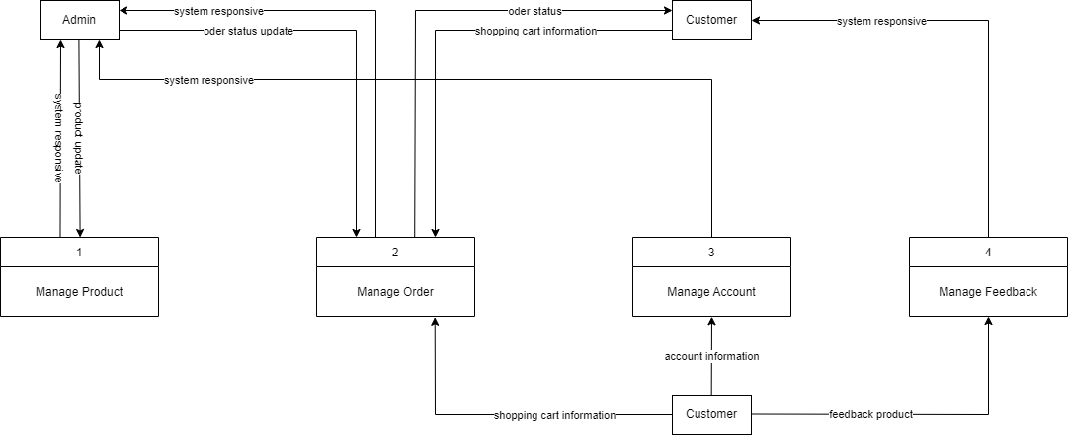

|  |
| --- |
| **A. Entity Relationship Diagram** |

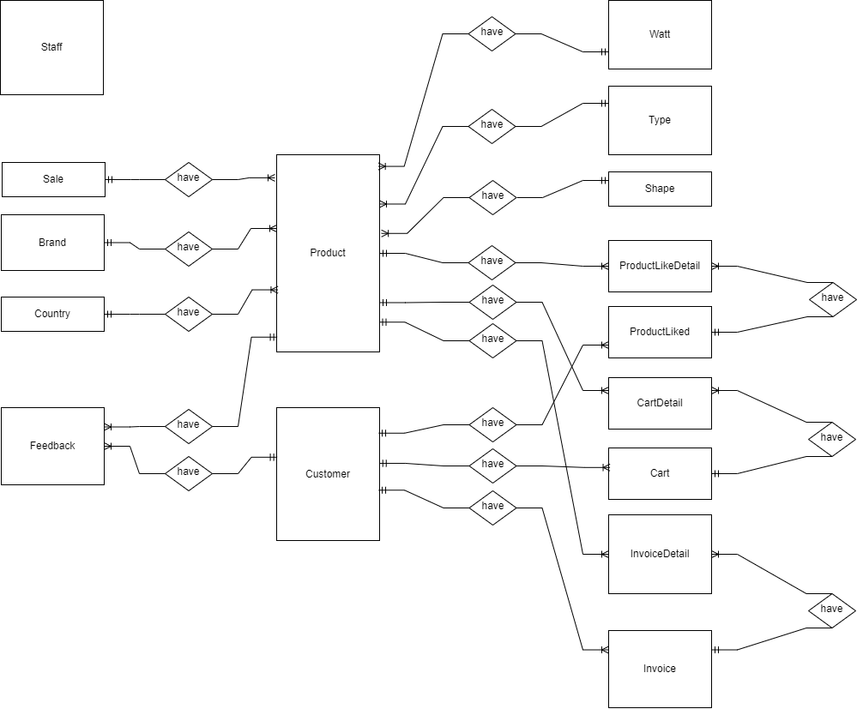

|  |
| --- |
| **B. Entity Attributes** |

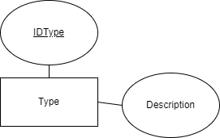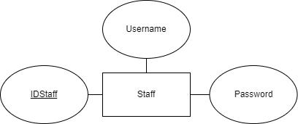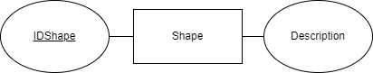

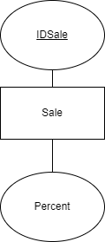

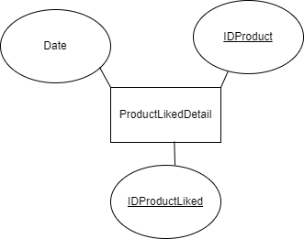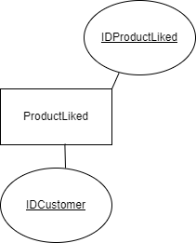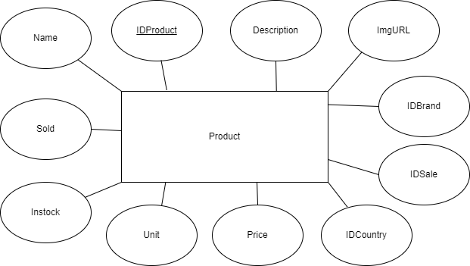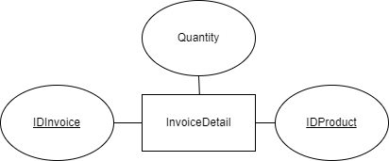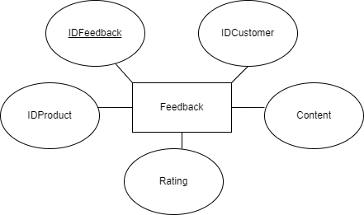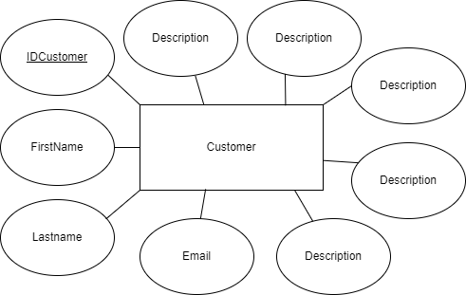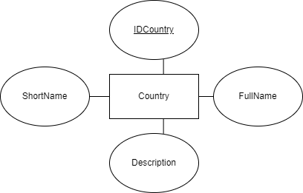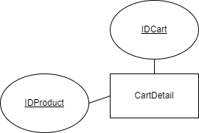

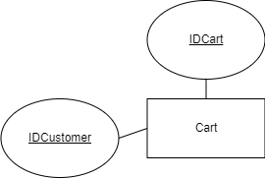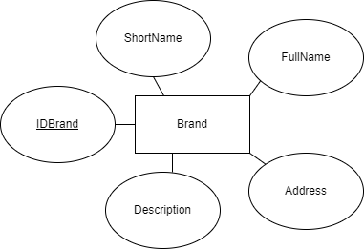

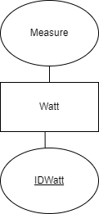

|  |
| --- |
| **A. Table Design** |

**Country**

|  |  |  |  |  |  |  |
| --- | --- | --- | --- | --- | --- | --- |
| No. | Name | Type | Null | Default | Comments | Extra |
| 1 | ID | int | No | None | PK | AUTO_INCREMENT |
| 2 | ShortName | varchar(100) | No | NULL |  |  |
| 3 | FullName | varchar(250) | No | NULL |  |  |
| 4 | Desc | text | Yes | NULL |  |  |

**Brand**

|  |  |  |  |  |  |  |
| --- | --- | --- | --- | --- | --- | --- |
| No. | Name | Type | Null | Default | Comments | Extra |
| 1 | ID | int | No | None | PK | AUTO_INCREMENT |
| 2 | ShortName | varchar(100) | No | NULL |  |  |
| 3 | FullName | varchar(250) | No | NULL |  |  |
| 4 | Address | varchar(500) | No | NULL |  |  |
| 5 | Desc | text | Yes | NULL |  |  |

**Product**

|  |  |  |  |  |  |  |
| --- | --- | --- | --- | --- | --- | --- |
| No. | Name | Type | Null | Default | Comments | Extra |
| 1 | ID | int | No | None | PK | AUTO_INCREMENT |
| 2 | Name | varchar(250) | No | NULL |  |  |
| 3 | Unit | varchar(50) | No | NULL |  |  |
| 4 | Price | float | No | NULL |  |  |
| 5 | CountryID | int | No | NULL | FK |  |
| 6 | BrandID | int | No | NULL | FK |  |
| 7 | ImgURL | varchar | No | NULL |  |  |
| 8 | Desc | text | Yes | NULL |  |  |
| 9 | Sold | int | No | NULL |  |  |
| 10 | InStock | int | No | NULL |  |  |
| 11 | ShapeID | int | No | NULL | FK |  |
| 12 | TypeID | int | No | NULL | FK |  |
| 13 | WattID | int | No | NULL | FK |  |
| 14 | SaleID | int | No | NULL | FK |  |

**Customer**

|  |  |  |  |  |  |  |
| --- | --- | --- | --- | --- | --- | --- |
| No. | Name | Type | Null | Default | Comments | Extra |
| 1 | ID | int | No | None | PK | AUTO_INCREMENT |
| 2 | FirstName | varchar(100) | No | NULL |  |  |
| 3 | LastName | varchar(100) | No | NULL |  |  |
| 4 | Email | varchar(250) | No | NULL |  |  |
| 5 | PhoneNumber | int(20) | No | NULL |  |  |
| 6 | Address | varchar(500) | No | NULL |  |  |
| 7 | Zip | int | No | NULL |  |  |
| 8 | Password | varchar(20) | No | NULL |  |  |
| 9 | Username | varchar(20) | No | NULL |  |  |

**ProductLikedDetail**

|  |  |  |  |  |  |  |
| --- | --- | --- | --- | --- | --- | --- |
| No. | Name | Type | Null | Default | Comments | Extra |
| 1 | Date | datetime | No | NULL |  |  |
| 2 | ProductLikedID | int | No | NULL | Combined Key |  |
| 3 | ProductID | int | No | NULL |  |

**ProductLiked**

|  |  |  |  |  |  |  |
| --- | --- | --- | --- | --- | --- | --- |
| No. | Name | Type | Null | Default | Comments | Extra |
| 1 | ID | datetime | No | None | PK |  |
| 2 | CustomerID | int | No | NULL | FK |  |

**CartDetail**

|  |  |  |  |  |  |  |
| --- | --- | --- | --- | --- | --- | --- |
| No. | Name | Type | Null | Default | Comments | Extra |
| 1 | CartID | int | No | NULL | Combined Key |  |
| 2 | ProductID | int | No | NULL |  |
| 3 | Qty | int | No | NULL |  |  |

**Cart**

|  |  |  |  |  |  |  |
| --- | --- | --- | --- | --- | --- | --- |
| No. | Name | Type | Null | Default | Comments | Extra |
| 1 | ID | int | No | None | PK |  |
| 2 | CustomerID | int | No | NULL | FK |  |

**Invoice**

|  |  |  |  |  |  |  |
| --- | --- | --- | --- | --- | --- | --- |
| No. | Name | Type | Null | Default | Comments | Extra |
| 1 | ID | int | No | None | PK | AUTO_INCREMENT |
| 2 | Date | datetime | No | NULL |  |  |
| 3 | InvoiceNumber | varchar(100) | No | NULL |  |  |
| 4 | CustomerID | int | No | NULL | FK |  |

**InvoiceDetail**

|  |  |  |  |  |  |  |
| --- | --- | --- | --- | --- | --- | --- |
| No. | Name | Type | Null | Default | Comments | Extra |
| 1 | InvoiceID | int | No | NULL | Combined Key |  |
| 2 | ProductID | int | No | NULL |  |
| 3 | Qty | int | No | NULL |  |  |

**Sale**

|  |  |  |  |  |  |  |
| --- | --- | --- | --- | --- | --- | --- |
| No. | Name | Type | Null | Default | Comments | Extra |
| 1 | ID | int | No | None | PK | AUTO_INCREMENT |
| 2 | Percent | float | No | NULL |  |  |

**Feedback**

|  |  |  |  |  |  |  |
| --- | --- | --- | --- | --- | --- | --- |
| No. | Name | Type | Null | Default | Comments | Extra |
| 1 | ID | int | No | None | PK | AUTO_INCREMENT |
| 2 | CustomerID | int | No | NULL | FK |  |
| 3 | ProductID | int | No | NULL | FK |  |
| 4 | Content | text | No | NULL |  |  |
| 5 | Rating | int | No | NULL |  |  |

**Watt**

|  |  |  |  |  |  |  |
| --- | --- | --- | --- | --- | --- | --- |
| No. | Name | Type | Null | Default | Comments | Extra |
| 1 | ID | int | No | None | PK | AUTO_INCREMENT |
| 2 | Measure | int | No | NULL |  |  |

**Shape**

|  |  |  |  |  |  |  |
| --- | --- | --- | --- | --- | --- | --- |
| No. | Name | Type | Null | Default | Comments | Extra |
| 1 | ID | int | No | None | PK | AUTO_INCREMENT |
| 2 | ShapeDesc | varchar(20) | No | NULL |  |  |

**Type**

|  |  |  |  |  |  |  |
| --- | --- | --- | --- | --- | --- | --- |
| No. | Name | Type | Null | Default | Comments | Extra |
| 1 | ID | int | No | None | PK | AUTO_INCREMENT |
| 2 | TypeDesc | varchar(20) | No | NULL |  |  |

**Staff­­**

|  |  |  |  |  |  |  |
| --- | --- | --- | --- | --- | --- | --- |
| No. | Name | Type | Null | Default | Comments | Extra |
| 1 | ID | int | No | None | PK | AUTO_INCREMENT |
| 2 | Password | varchar(20) | No | NULL | FK |  |
| 2 | Username | varchar(20) | No | NULL | FK |  |

|  |
| --- |
| **B. Relationship Diagram** |

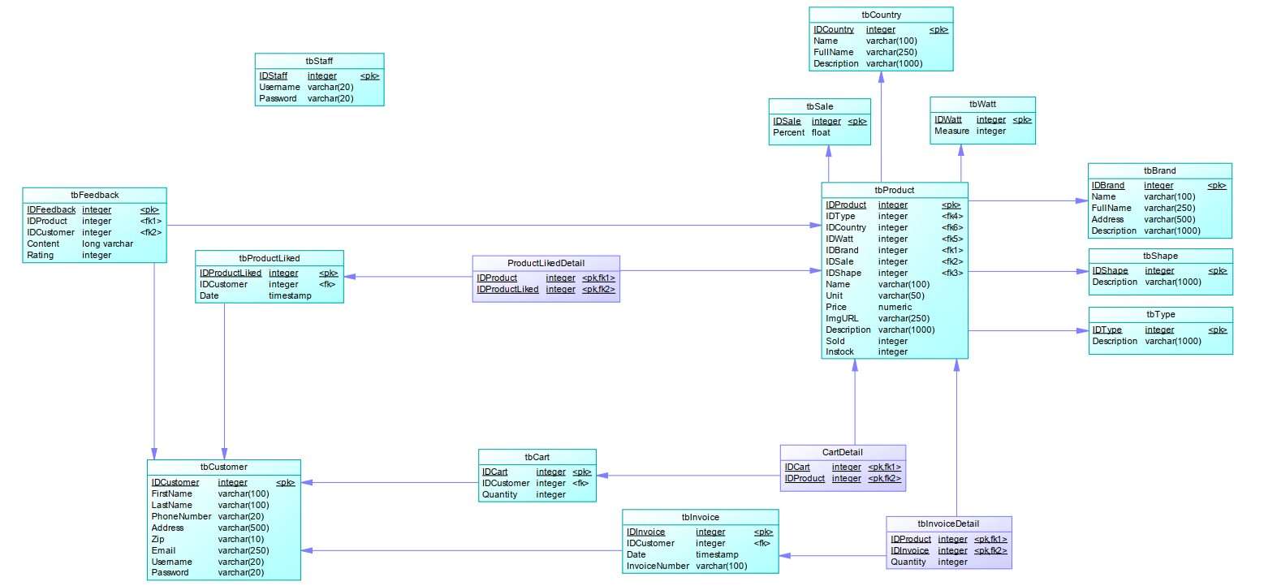

|  |
| --- |
| **SiteMap** |

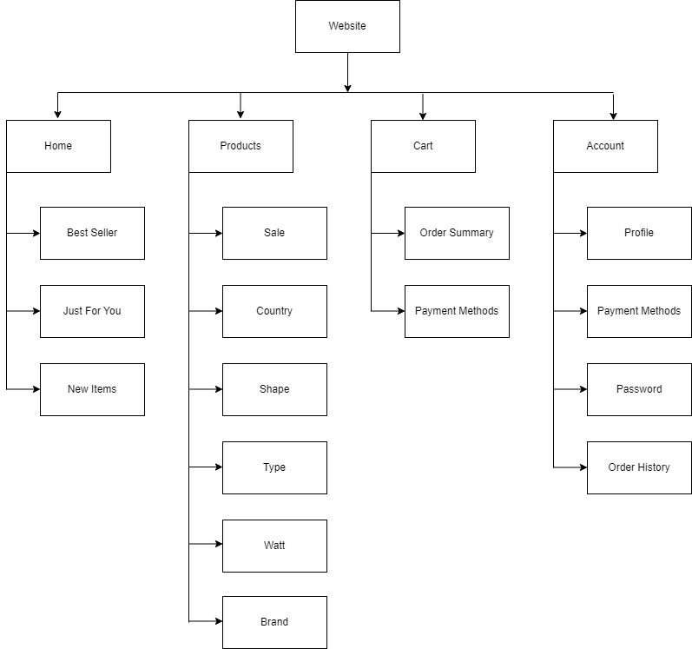

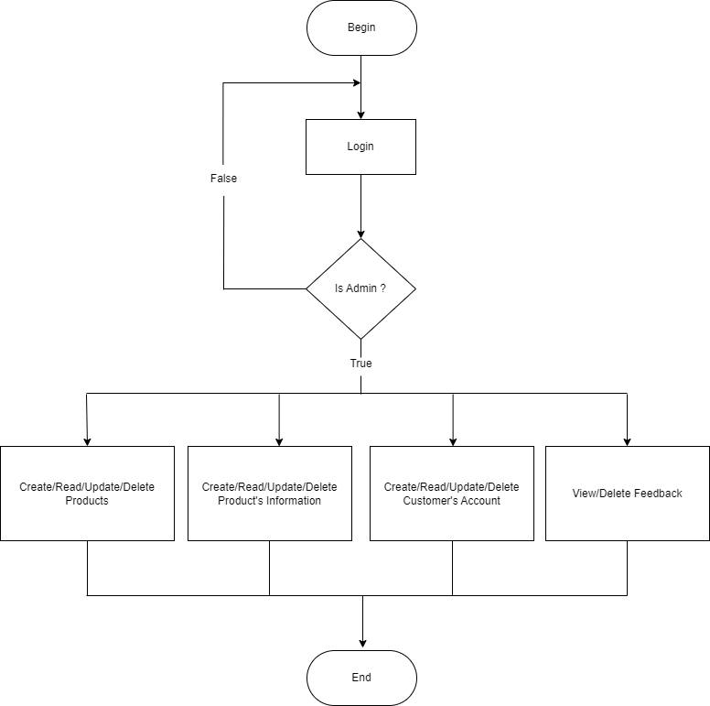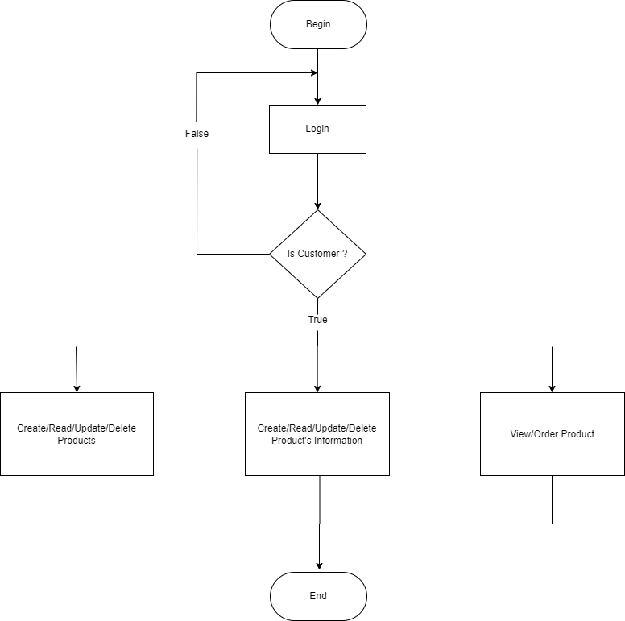

**Review 03**

|  |
| --- |
| **Screen shots** |

Các layout mô tả màn hình. Sinh viên có thể vẽ layout. Nếu không thể thì code HTML cơ bản rồi chụp lại hình màn hình.

1. **Homepage**

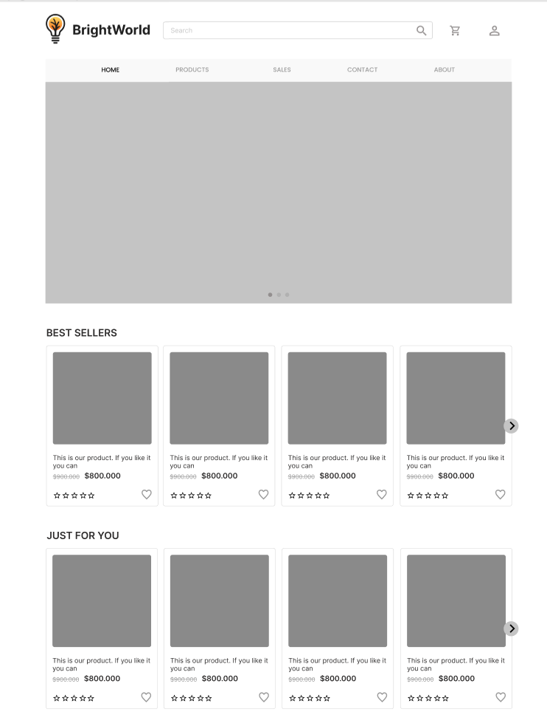

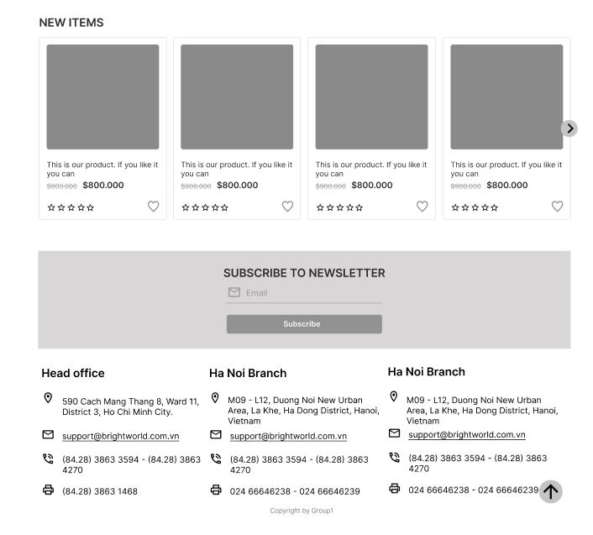

**Description:** This is a homepage of Bright World, the top of this page is a header, after that is a navigation bar. The main part of a homepage beside the slider also includes 3 sections: best sellers, just for you and new items. The footer of a homepage has 2 sections: subscribe and link to other information pages or contact information.

**From:** Sign in

1. **Sign in**



**Description:** When the user clicks on the human icon in the header, it leads to a sign in page. This form requires the user to enter an email address and a password. After clicking the login button, the user will be redirected to the homepage.

**To:** Homepage

1. **Sign up**

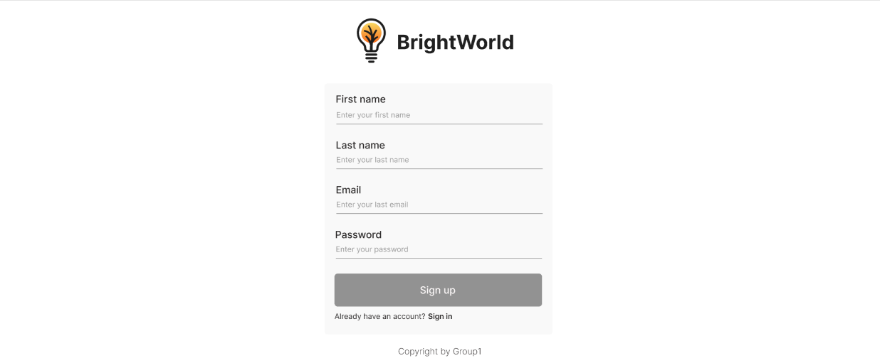

**Description:** If the user hasn’t created an account, he/she can click to Create new account in the sign in page and it will lead to this sign up page. This sign up form requires the user to enter 4 fields: first name, last name, email and password. After clicking the sign up button the user will be redirected to the homepage.

**To:** Sign in

1. **Sales**

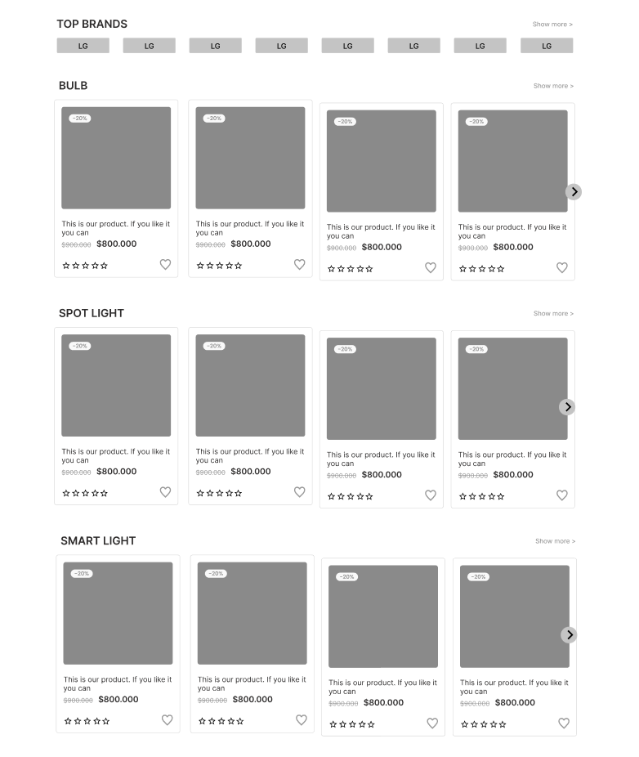

**Description:** When the user clicks on the Sales tag in navigation, it will lead to this page. The main part of this page contains 2 sections: top brands, and sale items (which includes the category of each product).

**From:** Navigation

**To:** Product Detail

1. **Product Category/Search Page**

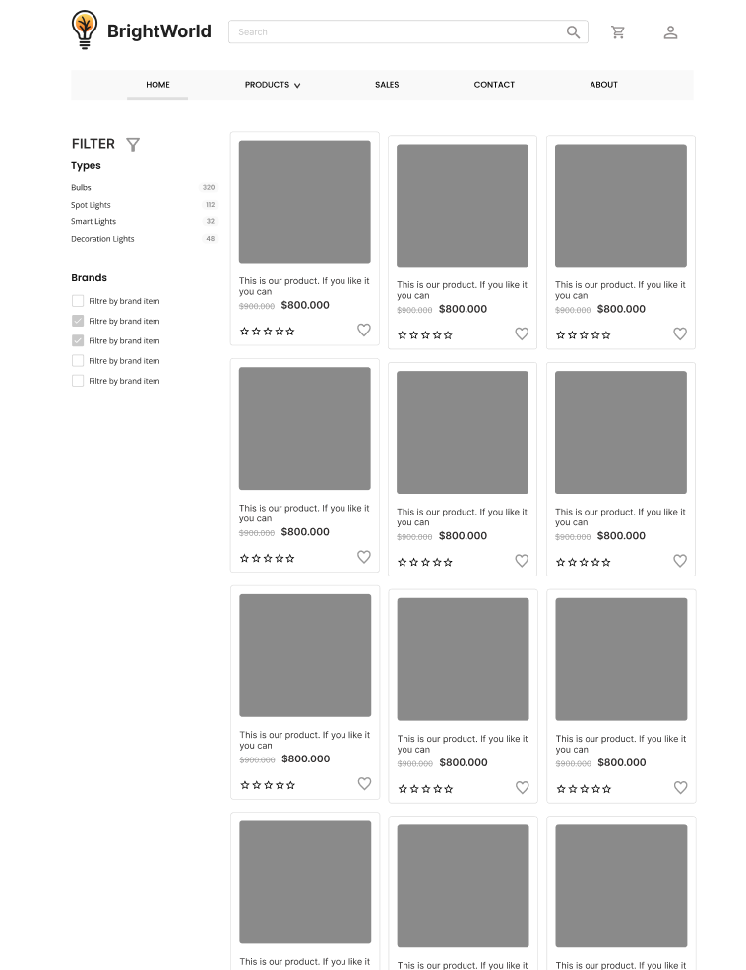

**Description:** When the user clicks on a specific category in the sub menu of the Products tag on navigation, it will lead to this page. The left part is a filter which contains filters by: light types, brands, rating and price. The right part is a result of a specific product.

**From:** Navigation

**To:** Product Detail

1. **Product Detail**

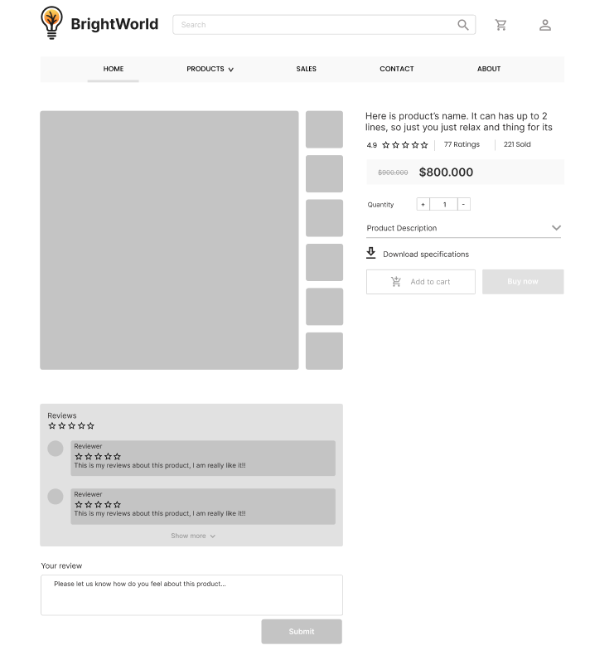

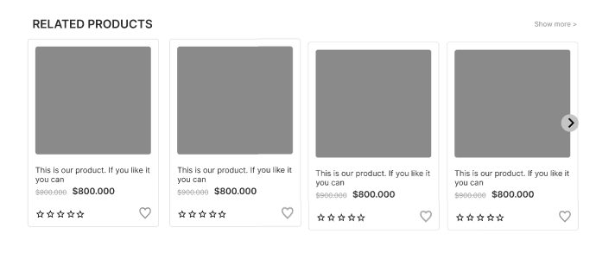

**Description:** When the user clicks on a specific product it will lead to this product detail page. Beside in detail information about the product, it also contains Call to Action buttons Buy now. Moreover, it also contains the Reviews part, this includes reviews of the other buyers, and the user can write reviews about this product. The last part of this page is the Related Products section.

**To:** Checkout

1. **Cart Dropdown**

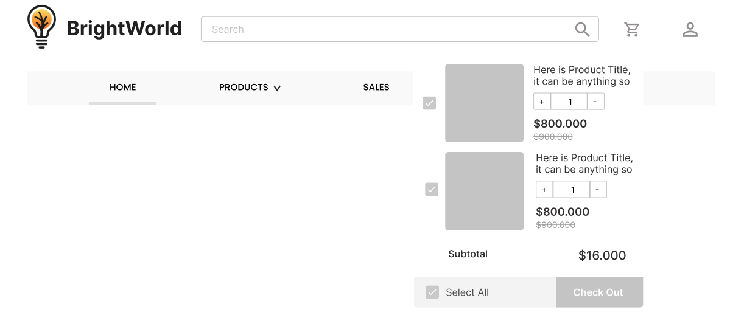

**Description:** When the user clicks on the cart icon in the header, the cart information will appear. It includes products that users have already added to cart, the user can select all items or remove items which they don’t have the intention to buy.

**To:** Checkout

1. **Checkout**

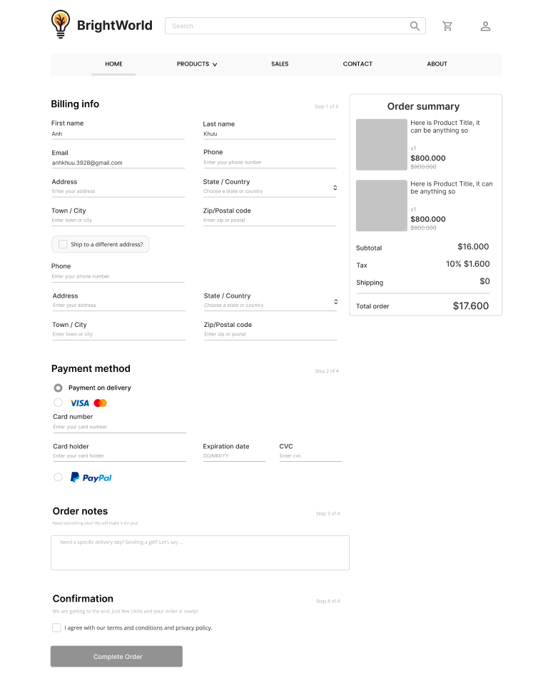

**Description:** After clicking the Check out button on the Cart or Buy now button in Product Detail Page, the user will be redirected to this checkout page. The left part of this page contains a form which requires the user to enter and the other side is the Order summary.

|  |
| --- |
| **Testing document** |

|  |  |  |
| --- | --- | --- |
| **Sr.No** | **Features Tested** | **Remarks** |
| 1 | Create, Update, Read, Delete Products | Done |
| 2 | Create, Update, Read, Delete Customers | Done |
| 3 | Create, Update, Read, Delete Feedbacks | Done |
| 4 | Create, Update, Read, Delete Invoices | Done |
| 5 | Create, Update, Read, Delete Carts | Done |
| 6 | Create, Update, Read, Delete Staffs | Done |

|  |
| --- |
| **Final checklist** |

|  |  |  |
| --- | --- | --- |
| **Sr.No** | **Aspected Tested** | **Suggestion/**  **Remarks** |
| 1 | Are all the users able to view the images and links? | Yes |
| 2 | Have all the views, modules and controllers been properly integrated and is the site function as a single page application? | Yes |
| 3 | Are the GUI content devoid of spelling mistakes? | Yes |
| 4 | Is the application user-friendly? | Yes |
| 5 | Is the Website launching correctly in all popular browsers? | Yes |
| 6 | Are all the forms validated with proper criteria? | Yes |
| 7 | Do all text links lead to the appropriate website? | Yes |
| 8 | Do all image links lead to the appropriate website? | Yes |
| 9 | Are all the images and links clearly visible on the page? | Yes |
| 10 | Does the Web page work properly in all the tested browsers? | Yes |
| 11 | Does the Web page take too long to be loaded fully? | Yes |
| 12 | Is the navigation sequences correct through all the Web pages on the site? | Yes |
| 13 | Is the JavaScript code working as expected in all click events? | Yes |
|  |  |  |
|  |  |  |

|  |  |  |  |  |  |  |  |  |
| --- | --- | --- | --- | --- | --- | --- | --- | --- |
| **No** | **Member** | **Contents** | | **Table Name** | **Activity Plan** | **Date of Preparation of Activity Plan** | | |
| **Planed Start Date** | **Actual Start Date** | **Actual Days** | **Status** |
| 1 | **Khưu Nguyễn Lan Anh** | Admin | *Product Management* | Products,  Brands | 14/10/2002 | 14/10/2002 | 5 | DONE |
| 2 | 14/10/2002 | 14/10/2002 | 5 | DONE |
| 3 | User | *View Product* | 14/10/2002 | 14/10/2002 | 5 | DONE |
| 4 | 14/10/2002 | 14/10/2002 | 5 | DONE |
|  |  |  |  |  |  |  |  |  |
| 1 | **Huỳnh Thanh Tú** | Admin | *Order Management* | Invoices,  Carts | 14/10/2002 | 14/10/2002 | 5 | DONE |
| 2 | 14/10/2002 | 14/10/2002 | 5 | DONE |
| 3 | User | *Add Order Management* | 14/10/2002 | 14/10/2002 | 5 | DONE |
| 4 | *Cart Management* | 14/10/2002 | 14/10/2002 | 5 | DONE |
|  |  |  |  |  |  |  |  |  |
| 1 | **Nguyễn Minh Sơn** | Admin | *Customer Management* | Customers,  Staffs | 14/10/2002 | 14/10/2002 | 5 | DONE |
| 2 | 14/10/2002 | 14/10/2002 | 5 | DONE |
| 3 | User | *Register* | 14/10/2002 | 14/10/2002 | 5 | DONE |
| 4 | *Personal Account Management* | 14/10/2002 | 14/10/2002 | 5 | DONE |
|  |  |  |  |  |  |  |  |  |
| 1 | **Vũ Đông Nam** | Admin | *Feedback Management* | Feedbacks, ProductLikeds | 14/10/2002 | 14/10/2002 | 5 | DONE |
| 2 | 14/10/2002 | 14/10/2002 | 5 | DONE |
| 3 | User | *Send Feed back, Comment* | 14/10/2002 | 14/10/2002 | 5 | NOT DONE |
| 4 | *Personal Feedback Management* | 14/10/2002 | 14/10/2002 | 5 | DONE |